**Cover Letter of Transmittal**

Device for Micro Patterning Freeform Optics Project

9201 University City Blvd

Charlotte, NC 28223

May 10, 2010

Senior Design Committee

9201 University City Blvd,

Charlotte, NC 28223

Senior Design Committee,

This document contains an overview of the progress made by the UNCC_FFGRAT Senior Design Team during the Fall 2015 and Spring 2016 semesters with respect to designing and testing a device for micro-patterning an optic of arbitrary (free form) shape using a diamond tool and stylus.

The device must be able to produce a linear grating pattern on a flat copper workpiece with an optical surface; this grating should have an uncertainty in pitch and depth of +/- 0.1 μm. The device must also be able to operate on a Moore Nanotechnology 350 FG precision mill, as well as a Precitech Nanoform 350 precision lathe. The system will be used by CEFO to add polarization filters, anti-reflective properties, and diffractive optical functions to optics of arbitrary shape. The overall design of the precision micro-patterning apparatus consists of three main components: the monolithic base-flexure, voice coil actuator, and the control system.

The final design is a double flexure based system modeled after an atomic force microscope (AFM). In this design, the tool tip will act like the probe of the AFM; transferring the force at the tool/part interface. The capacitance gages will measure the tool tip displacement by detecting the displacement of the inner flexure. A force will be applied to the outer flexure by the voice coil to move the entire apparatus in order to keep the force at the tool tip constant.

Testing of the device on a copper test flat shows an uncertainty in depth of +/- 0.4 μm. Testing of tilted flats has been completed and indicates proof of concept. It is recommended that further research and testing of this design is warranted.

|  |  |
| --- | --- |
| **Deliverable** | **File Name** |
|  |  |
|  |  |
|  |  |
|  |  |
|  |  |
|  |  |
|  |  |
|  |  |
|  |  |
|  |  |
|  |  |
|  |  |
|  |  |
|  |  |
|  |  |
|  |  |

**Division of Duties Summary Table**

Each team member will provide a summary of what they accomplished relative to the project using the table below. Enter each member’s name in the first row, and list the major project tasks in the first column. Then enter a percentage of contribution for each member on each task. The total team contribution for every task should add up to 100% in the far right hand column.

|  |  |  |  |  |
| --- | --- | --- | --- | --- |
|  | Alexander Blum | Preston Hamby | Spencer Greer | Total (should = 100%) |
| Flexure design and characterization | 80 | 10 | 10 |  |
| Initial controller design | 70 | 20 | 10 |  |
| Solid model of design | 95 | 5 | 0 |  |
| Manufacturing plan | 15 | 70 | 15 |  |
| Control system implementation and tuning | 10 | 0 | 90 |  |
| Testing of device | 30 | 10 | 60 |  |
| Documentation | 33.3 | 33.3 | 33.3 |  |

**Xxxxxx Project – Final Project Report – Senior Design II**

|  |  |  |  |
| --- | --- | --- | --- |
| Date | Revision | Author | Comments |
| 2016-04-29 | A | Alex Blum |  |
|  |  |  |  |
|  |  |  |  |
|  |  |  |  |

Table of Contents

1 Overview of this Document 1

2 Project Overview / Statement of Work Summary 1

3 Design Narrative 1

4 Test Report 1

5 Evaluation of Prototype/ Model/ System as Compared to Project Performance and Requirements Document 2

6 Recommendations for Further Development 2

7 Impact 2

8 Bill of Materials (BOM 2

9 Budget 2

10 Conclusions 2

11 References 2

12 Appendices 2

# Overview of this Document

This document contains the design details for the work completed by the UNCC_FFGRAT Senior Design 1 Team along with future plans to be conducted next semester in Senior Design II. The purpose of this project is to design, test and implement a device for micro-patterning an optical surface of arbitrary (freeform) shape using a diamond tool or stylus. After several iterations and two design reviews a final design has been chosen by the team.

# Project Overview / Statement of Work Summary

A device for micro-patterning optics of various shapes using a diamond-tip tool or a stylus was designed and tested for this project. These micro-patterns will be used to enhance or change the optical function and capabilities of freeform optics. Initial testing was conducted on copper test flats in order to judge the efficacy of the design, additional testing was conducted on tilted flats in order to test the feasibility of tracking freeform surfaces. If funding is secured based on this proof of concept additional testing will be performed by producing gratings on free form optics.

# Design Narrative

The following section describes the design chosen by the team that is capable of meeting all of the design requirements listed above, as well as the manufacturing processes used to realize this design.

***3.1 Flexure Design***

The overall design of the precision micro-patterning apparatus consists of three main components: the monolithic base-flexure, voice coil actuator, and the control system. The design of the system begins with the flexure. Proper flexure design governs the displacement range, resolution, natural frequency, and thermal time constant of the system. The flexure system was designed to provide a displacement range of ±20 μm, with a resolution of ±0.1 μm and a natural frequency of 200 Hz.

A monolithic base-flexure design was chosen to allow the voice coil to be mounted and coupled to the flexure with tighter tolerances, reducing assembly-related error. Figure 1 shows the completed design.

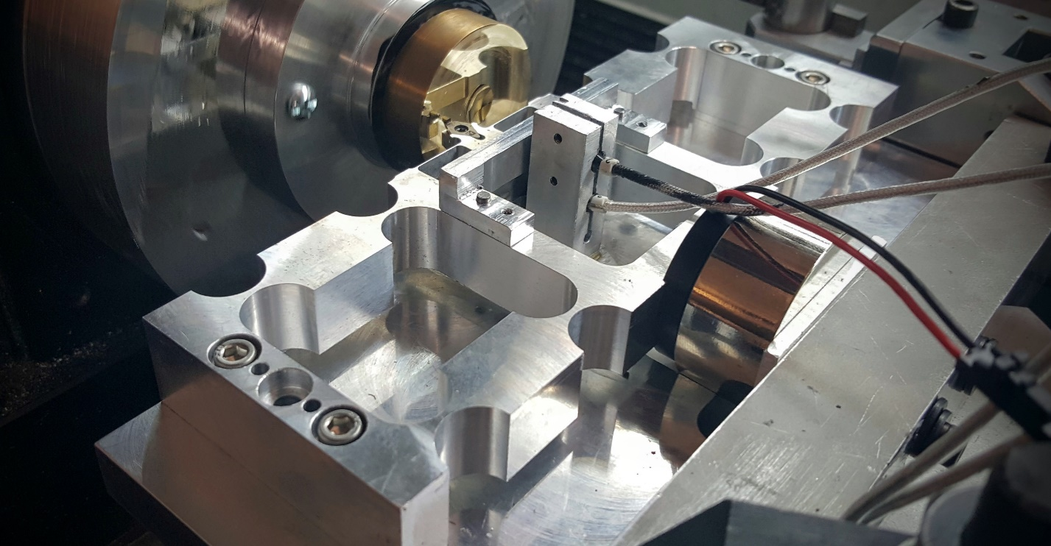

Figure - Completed Grating Device

***3.2 Control System Design***

A series of LabVIEW programs were developed in order to precisely measure and control the device. A NI myRIO device is used in conjunction with two Lion Precision capacitance gages to measure real-time positions of the inner and outer flexures. The myRIO is also used to send an output signal to a custom-built amplifier that turns the input voltage into a proportional current that drives the voice coil.

The first LabVIEW program (APENDIX) constantly updates the myRIO with the positions of the inner and outer flexures and stores these positions as variables. These variables are transferred from the myRIO to the host computer.

The second LabVIEW program (APENDIX) is the main controller of the system. This program reads in the variables from the previous program and uses them to generate a difference in position between the inner and outer flexures. This measured difference in position is compared to the desired difference in position and generates an error. The position error is converted to a force error based on the stiffness calibration curves for the flexures. A proportional-integral (PI) control feedback loop takes this error and continuously updates the program with the current error of the system. This force error is used to generate a command voltage given to the voice coil using the force-to-voltage calibration data collected from testing the voice coil. This commanded voltage is output from the myRIO and sent through an amplifier that generates a current proportional to the voltage. This current drives the voice coil and actuates the system.

The PI controller was tuned in order to reject the disturbance at the fastest, stable rate. Once tuned, the controller was able to reject a disturbance within 50 ms. Figure 3 shows the controllers response to a disturbance.

Figure 3- PI Controller Disturbance Rejection

***3.3 Manufacturing***

# Testing

Testing was performed on a Precitech Nanoform 350 precision lathe; Figure 2 shows a top view for the coordinate system of the machine.

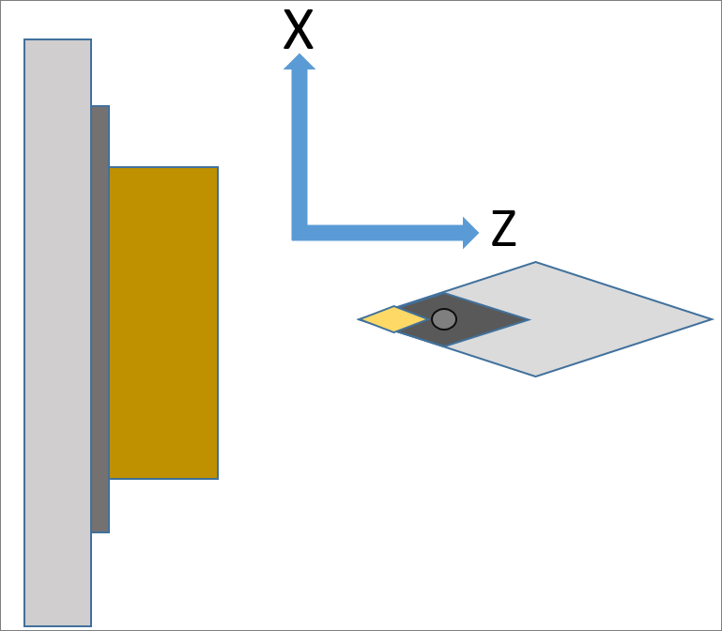

Figure 2- Precitech Coordinate System

***4.1 Calibration***

The capacitance gages were mounted to the worktable of the Precitech and the machine was jogged in the Z direction (APPENDIX). The corresponding voltages were recorded by the capacitance gages in order to achieve a voltage-to-displacement relationship. Figure 3 shows the calibration results for the capacitance gage.

Figure 3- Capacitance Gage Voltage to Displacement

The voice coil was mounted to the outer flexure and housing of the device and actuated through LabVIEW over a variety of voltages. The capacitance gage was used to measure the displacement of the outer flexure over the different voltages. This data was compiled to give a voltage-to-displacement relationship for the voice coil and outer flexure. Figure 4 shows the calibration results for the voice coil and outer flexure combo.

Figure 4- Voice Coil/Flexure Voltage to Displacement

***4.2 Test Results***

Tests performed to determine if the requirements and specifications described in the appropriate document are met, with description of testing and representative data and discussion of results. [Detailed test data to be included as appendices, but discussed in the narrative]

The device was mounted to a Precitech Nanoform 350 precision lathe by clamping the housing of the device to the worktable. A 50 mm diameter brass flat was mounted onto a work piece holder using blocking pitch. The holder was mounted onto the Precitech spindle and the tool tip of the device was touched off; this Z position was programmed into the Precitech as the nominal Z position of the tool tip. Commanding the tool tip to a negative Z coordinate specified a depth of cut for the test. Once this depth of cut was achieved, the capacitance gages were adjusted to have a differential distance of zero. The control system was commanded to actuate the device in such a way that this differential distance between the two capacitance probes remained as close to zero as possible. By keeping the differential distance close to zero, the depth of cut remained constant throughout the test. Table 1 shows the parameters used for each of the tests conducted on the brass flat.

Table 1 - Parameters for Testing

|  |  |  |  |  |  |  |  |  |
| --- | --- | --- | --- | --- | --- | --- | --- | --- |
| Test # | DOC (mm) | Feed (mm)/Rev | Spindle Speed (RPM) | Feedrate (mm/min) | Kp | Ki | ms_timer (ms) | Oil |
| 1 | 0.015 | 0.1 | 1 | 0.1 | 0.3 | 0.1 | 10 | N |
| 2 | 0.015 | 0.1 | 1 | 0.1 | 0.25 | 0.08 | 10 | N |
| 3 | 0.015 | 0.1 | 1 | 0.1 | 0.3 | 0.1 | 10 | Y |
| 4 | 0.015 | 0.1 | 1 | 0.1 | 0.2 | 0.1 | 10 | Y |
| 5 | 0.015 | 0.1 | 1 | 0.1 | 0 | 0 | 10 | Y |

Run 1 tested the system at the original Kp and Ki values used to tune the PI controller; using these variables, the system response time was around 0.05 ms. The error between the desired and measured positions was around ± 2 microns. Figure 1 shows the gratings created during run 1.

Run 2 tested the system at slightly smaller Kp and Ki values in hopes of correcting error overshoot. These smaller coefficients slightly decreased the initial overshoot of the system. The error between the measured and desired differential distances was not improved during this run. Figure 2 shows the gratings created during run 2.

Run 3 tested the system at the same Kp and Ki values from run 1, but a layer of oil was added between the magnet and the inner flexure to provide viscous damping. The error between the measured and desired differential distances was not improved during this run. Figure 3 shows the gratings created during run 3.

Run 4 tested the system at the same Ki value from run 1, but a 33% smaller Kp value. Dropping this proportional coefficient drastically decreased the error overshoot experienced by the system, while keeping the response time nearly the same. The error between the desired and measured positions was around ± 0.5 microns for this run. The grating generated during test 4 had a standard deviation of 0.42 microns. Figure 4 shows the gratings created during run 4.

Run 5 was a control test, which the system was turned off while the Precitech was commanded to keep a constant depth of cut. Figure 5 shows the grating generated by run 5.

# Evaluation of Prototype/ Model/ System as Compared to Project Performance Specification Document

This section builds on the Test Results section above and specifically addresses any shortcomings the project might have experienced in meeting the requirements and performance specifications defined.

# Recommendations for Further Development

How could the project be refined, what should be addressed in the next iteration, etc.?

# Impact

All projects have aspects with societal impact and ethical considerations that should be identified and articulated as appropriate for your project. Discuss how your project and/or design may have local, regional or global impact. Are there any societal or ethical considerations that should be considered before implementation? Hint: It may be a good idea to discuss this section with your mentor and supporter (if applicable) for additional clarity as needed.

# Bill of Materials (BOM

A complete list of parts for all assemblies and sub-assemblies is included. The (BOM) details each item, quantity, unit cost, total cost and source of each item (i.e., vendor). Note: No developmental costs (software, tools, etc.) are included in the BOM.

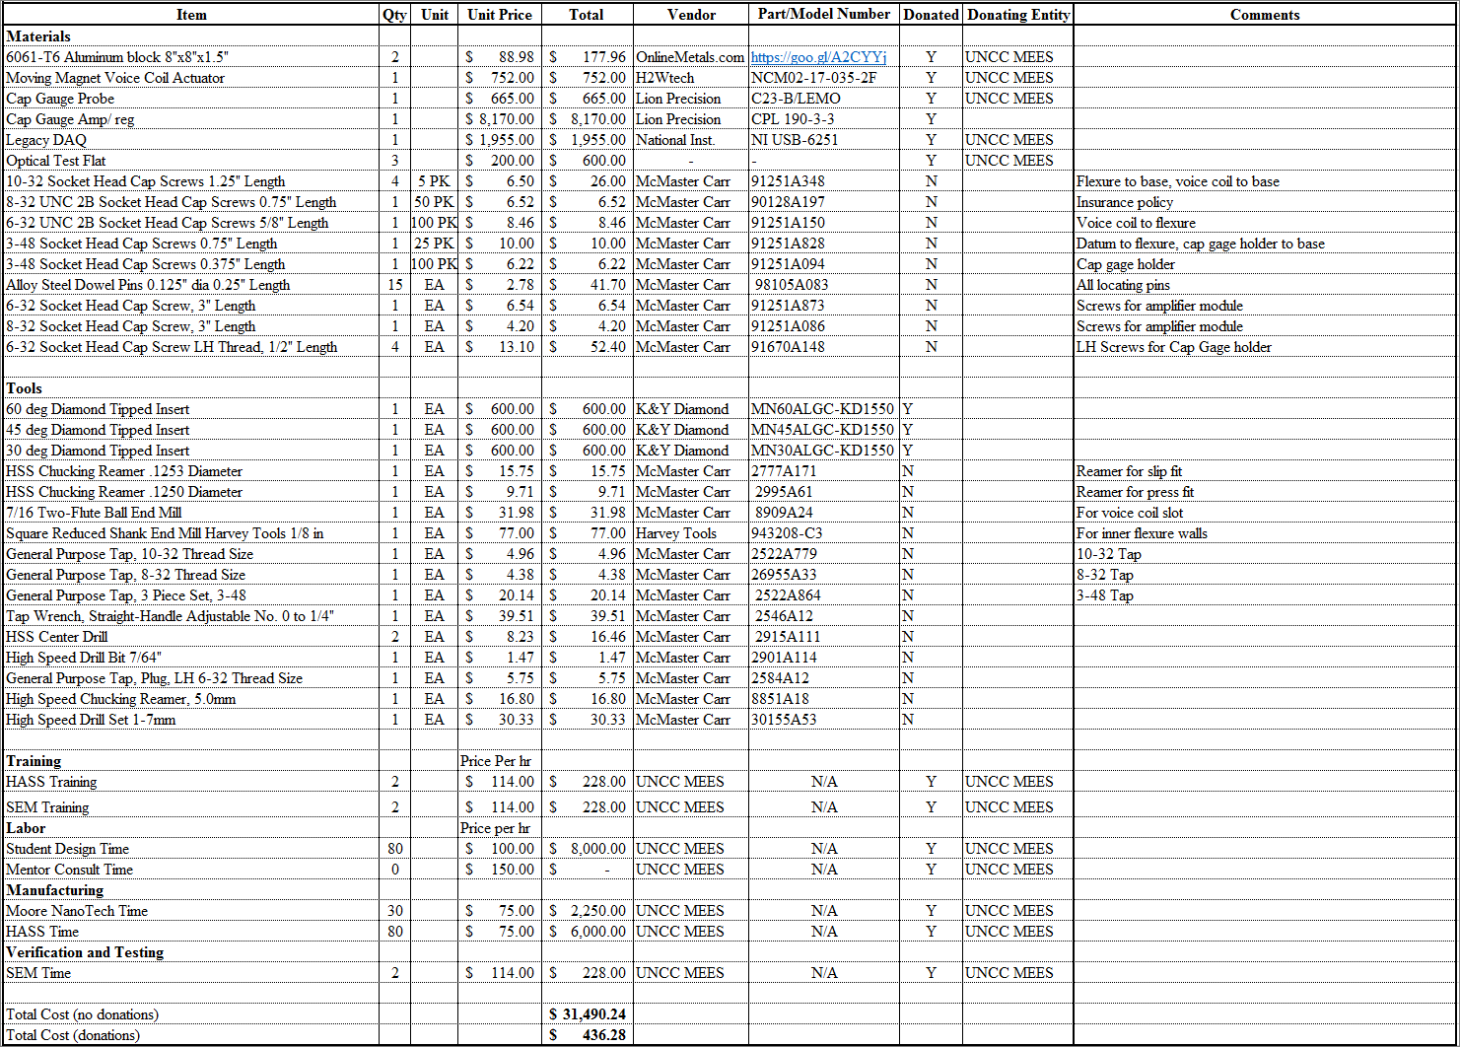

# Budget

This section should contain two items with appropriate narrative:

1. A budget plan for development tools and labor needed to complete the project.
2. A final budget that incorporates the BOM and budget plan detailed in (1).

# Conclusions

Summarize the entire project, process and results.

# References

Use the author-date Chicago Manual of Style reference format (link provided on the Moodle site). All references must be cited within the document narrative.

# Appendices

All raw data, spec sheets, tables, plots, CAD drawings, schematics, computer code, budgets, bill of materials, etc., that are not specifically included in the narrative. Note that all material in appendices must be referred to in the narrative and each type of material should have a separate appendix with a unique title. These supporting documents in the native file format should be included in the Comprehensive Package assignment (see sample SD2 Final Report posted on Moodle).

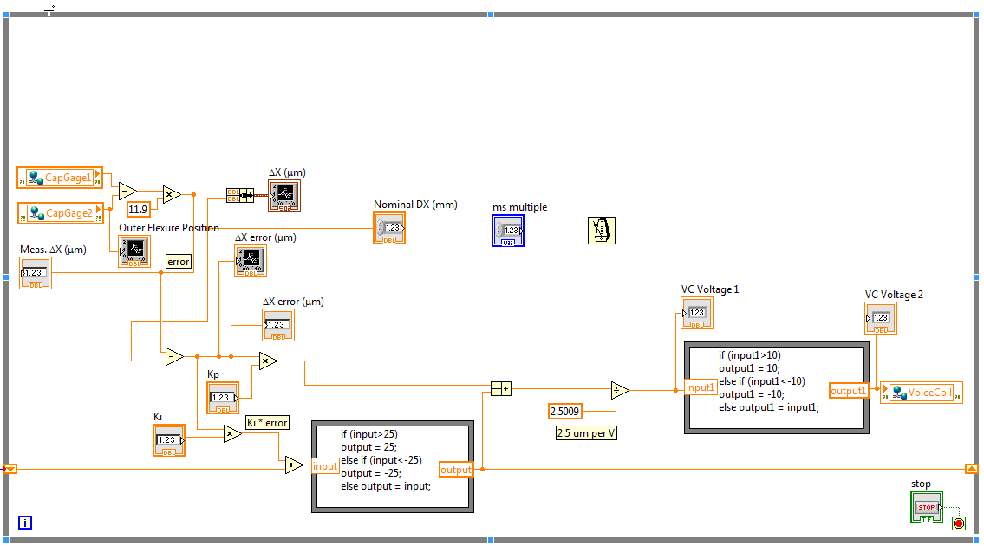

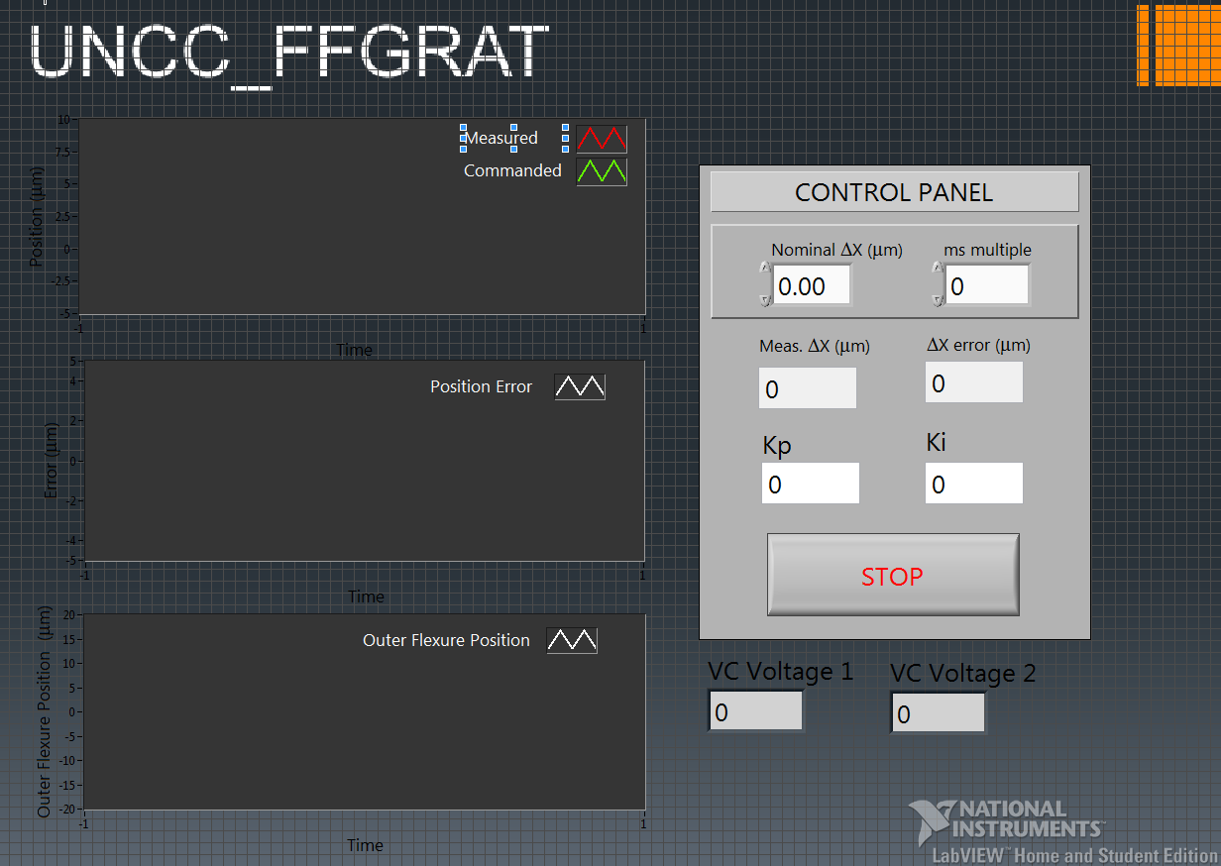

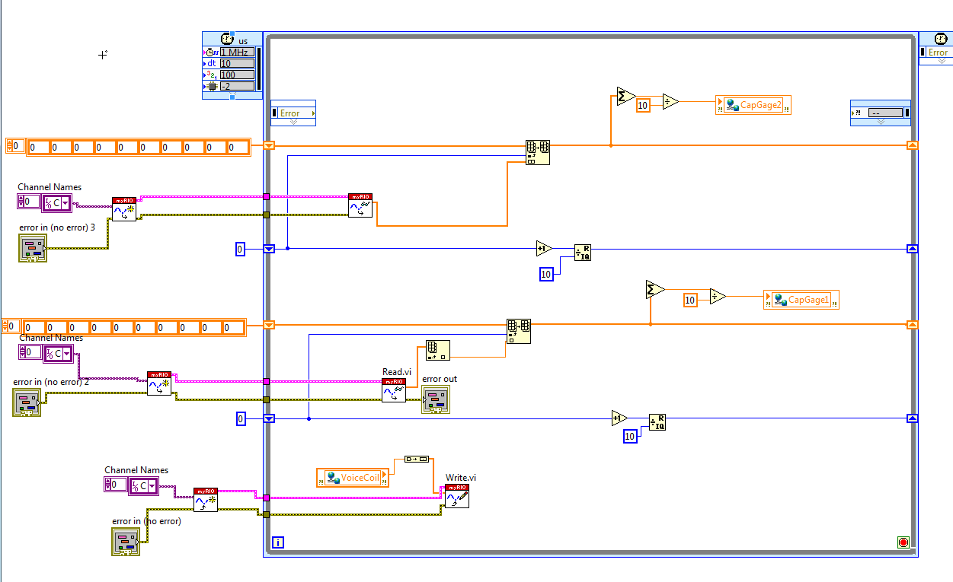

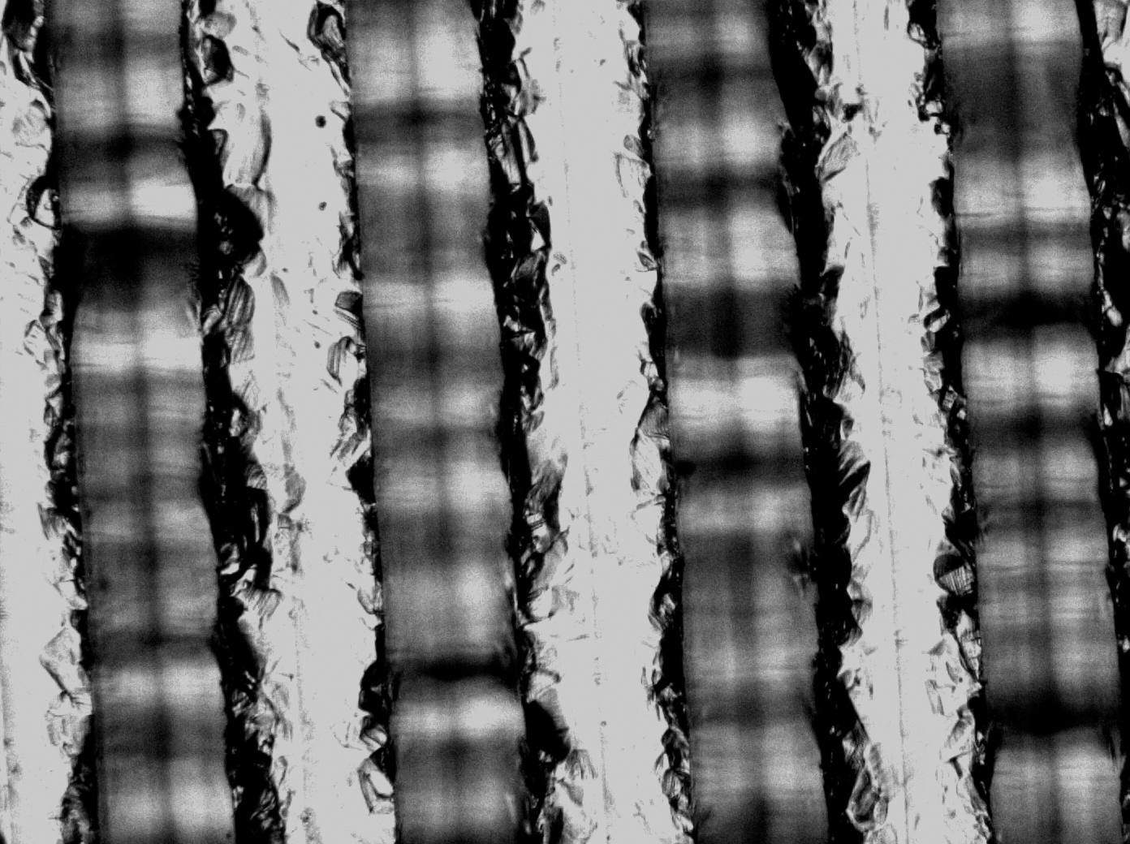

Figure - Run 1